CLMS SOFTWARE
EIC Master:
Engineer master records with their status. You can add, edit particular records and can export all records in excel sheet.
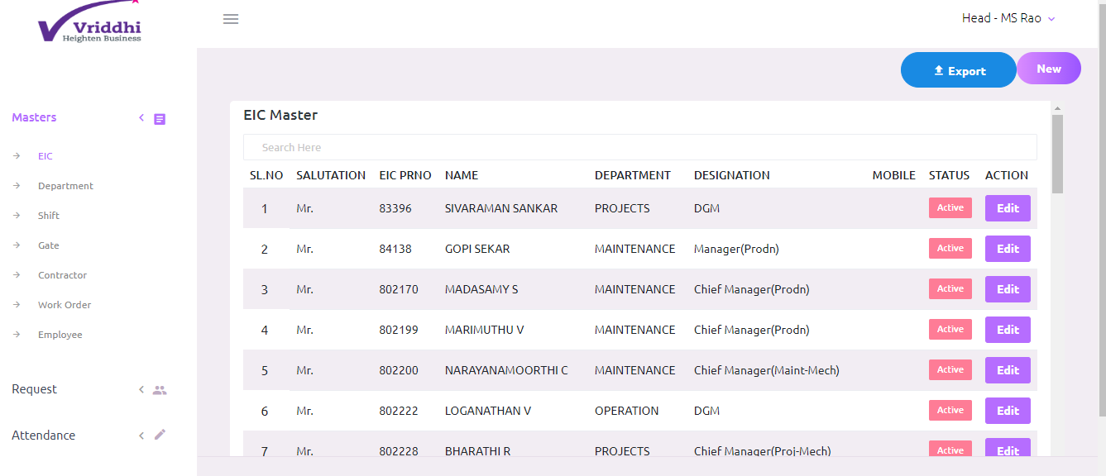

Department Master:
Department master records with their status. You can add, edit particular records and can export all records in excel sheet.
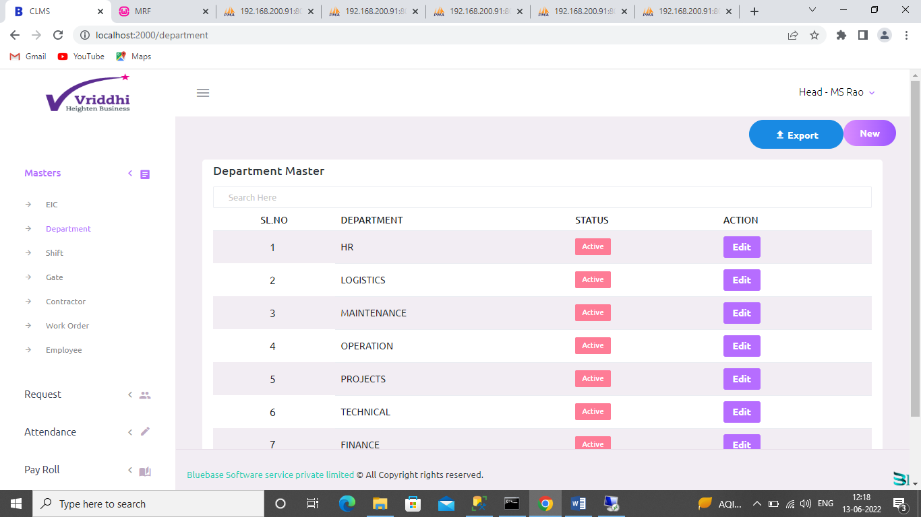

Shift Master:
Shift master records with their status. You can add, edit particular records and can export all records in excel sheet.
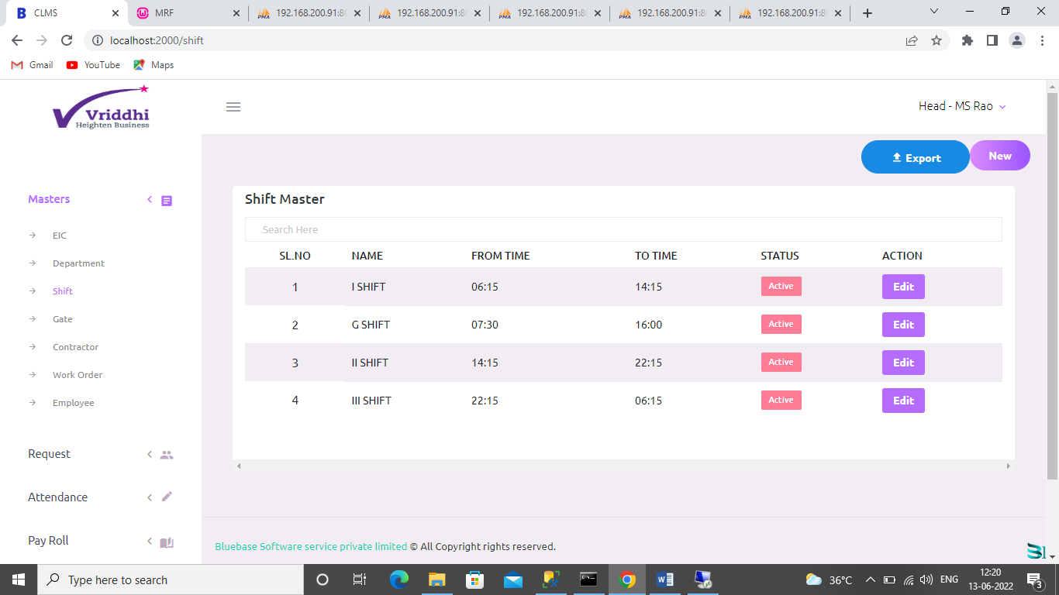
Gate Master:
Gate master records with their status. You can add, edit particular records and can export all records in excel sheet.
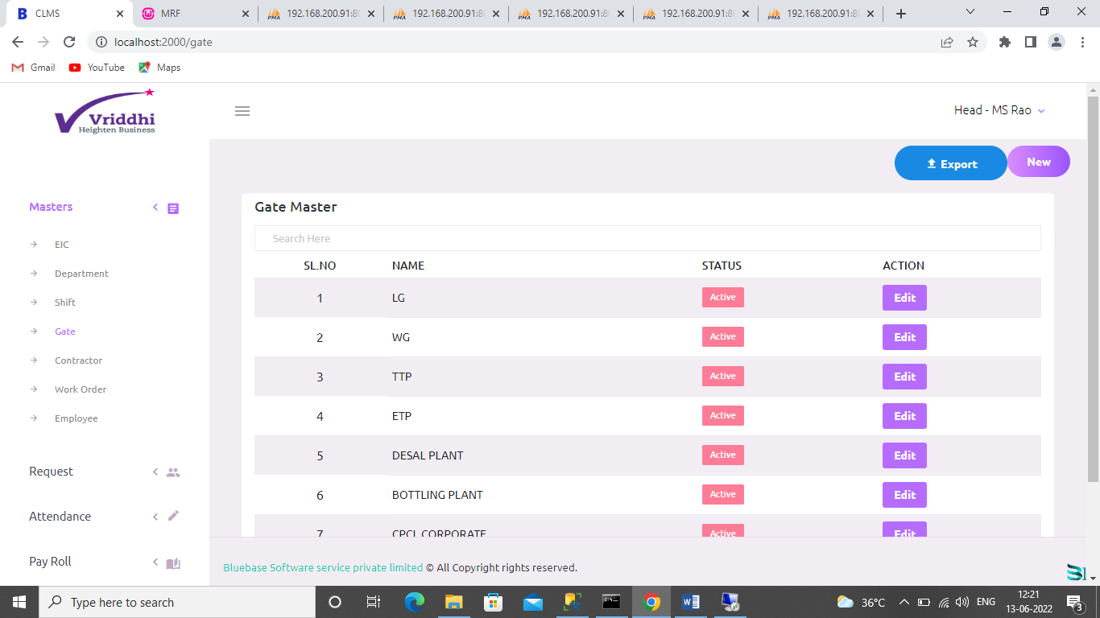

Contractor Master:
Contractor master records with their status. You can add, edit particular records and can export all records in excel sheet.

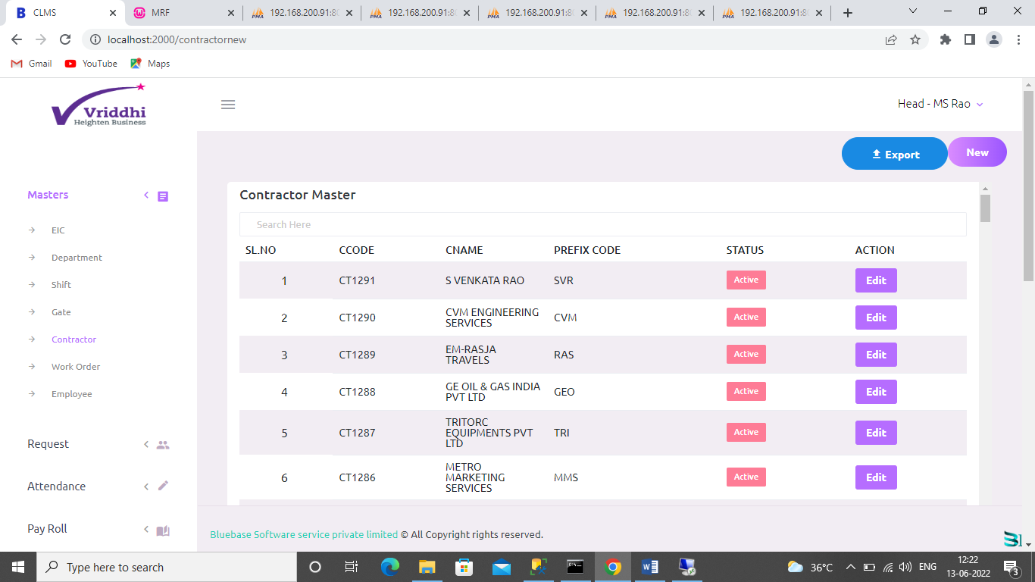
Work Order Master:
Work order master records with their status. You can add, edit particular records and can export all records in excel sheet.
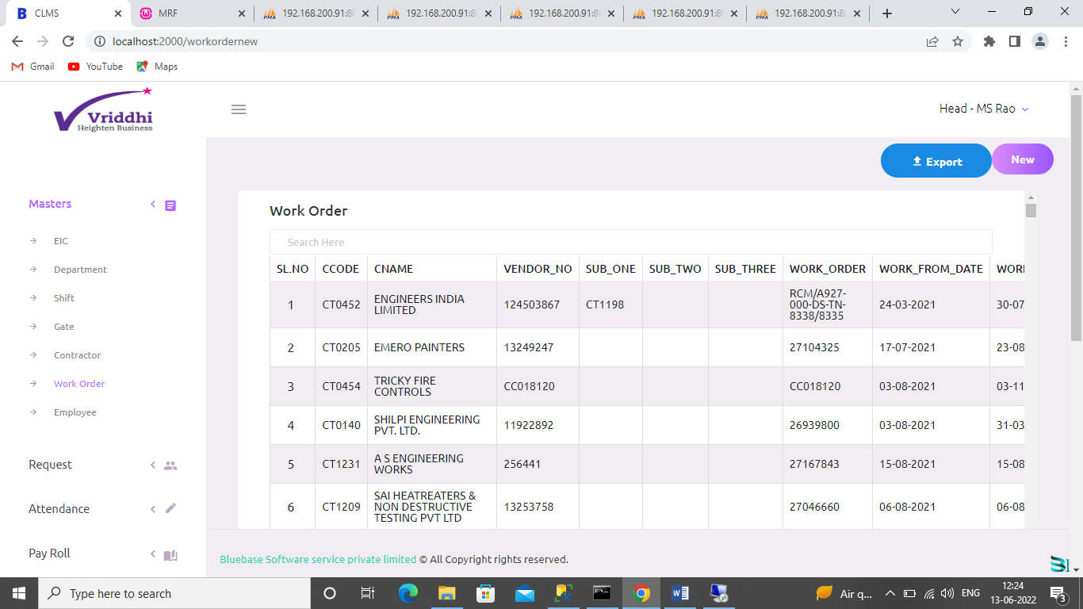
Request Transfer :
This is the transfer list of employees from one work order to the other.

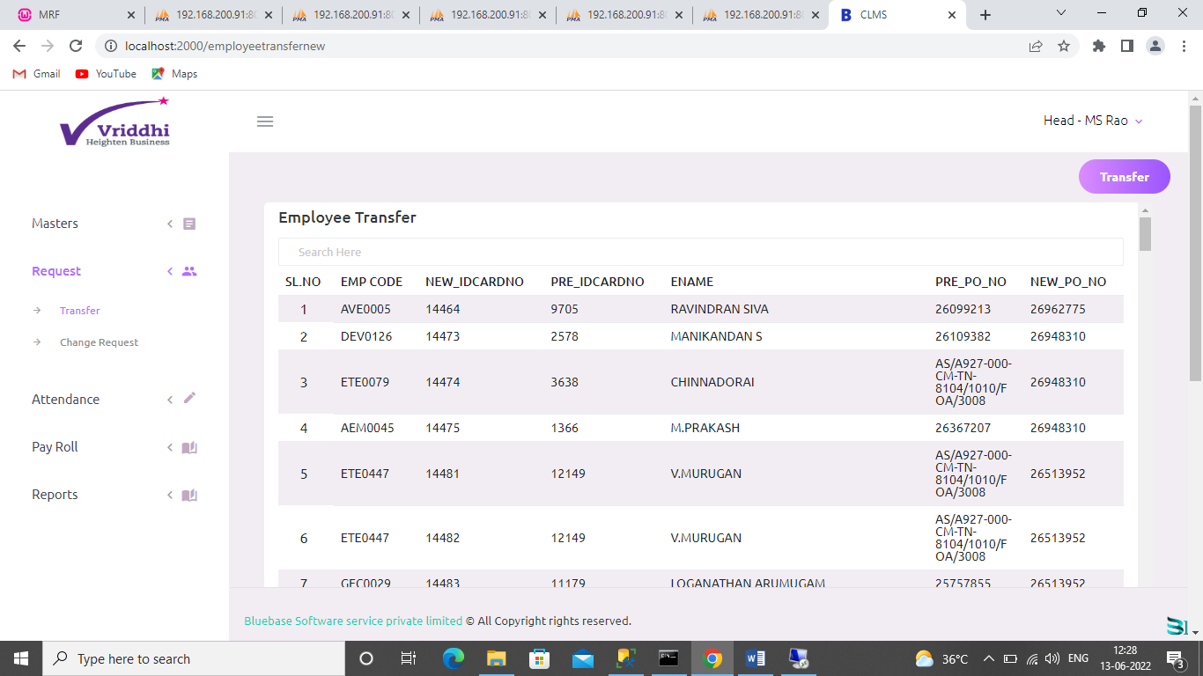
Here is the employee where transferred from one work order to other Work order.
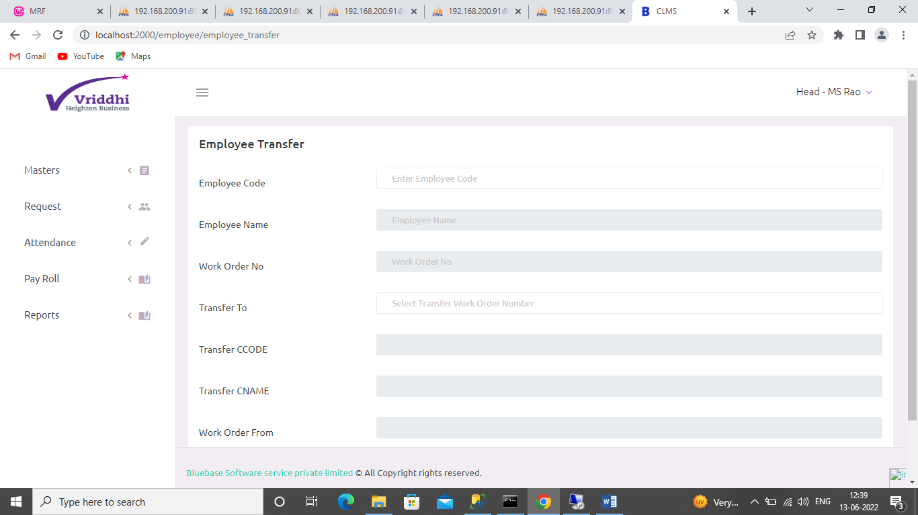

Attendance In-Out :
This is the attendance report of given contractor with from date and to date.
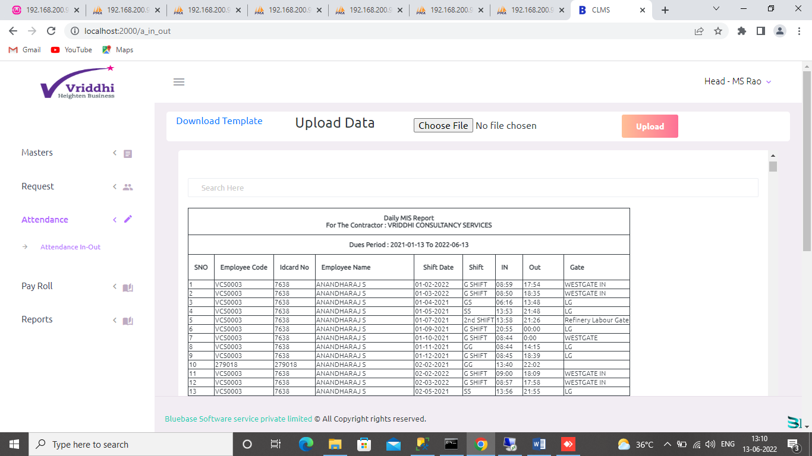
Payroll generation:
This menu is used to generate payroll.
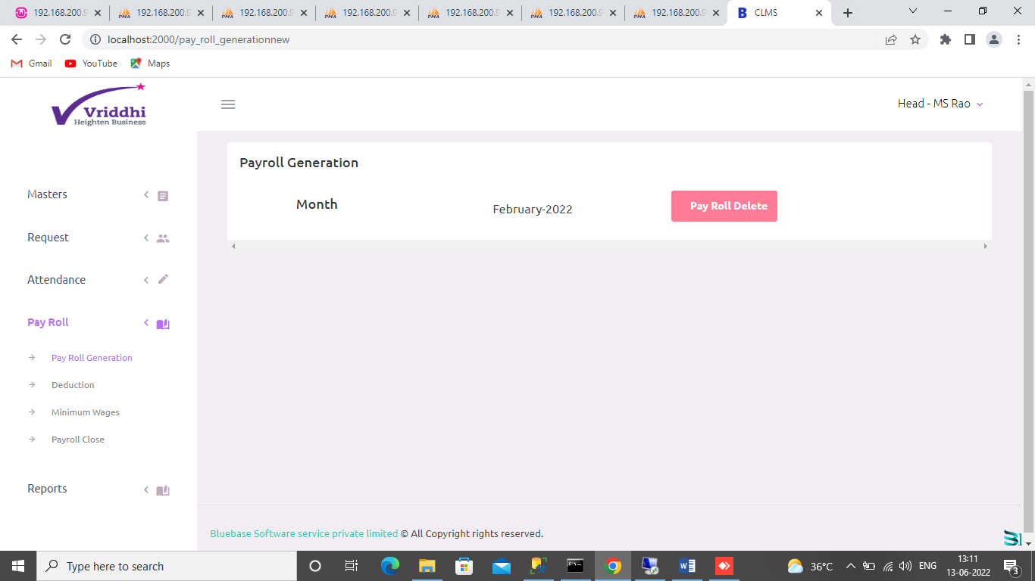

Deduction:
This is the deduction list where you can add,take print and export in excel.
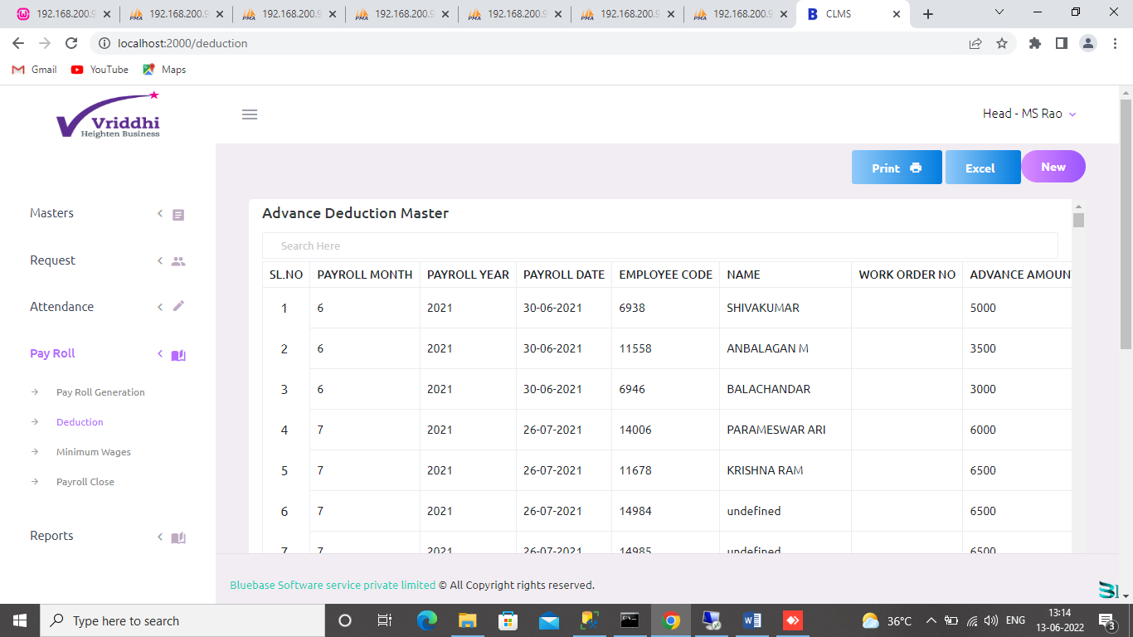
Payroll Close:
Here you can close the payroll.
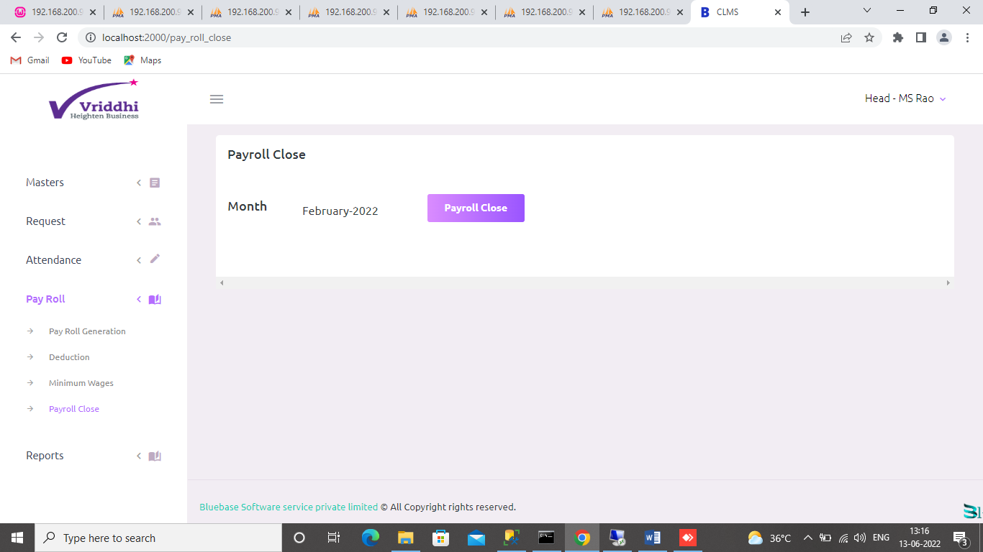
Wage slip 1 Report:
This is the report for wage slip 1.
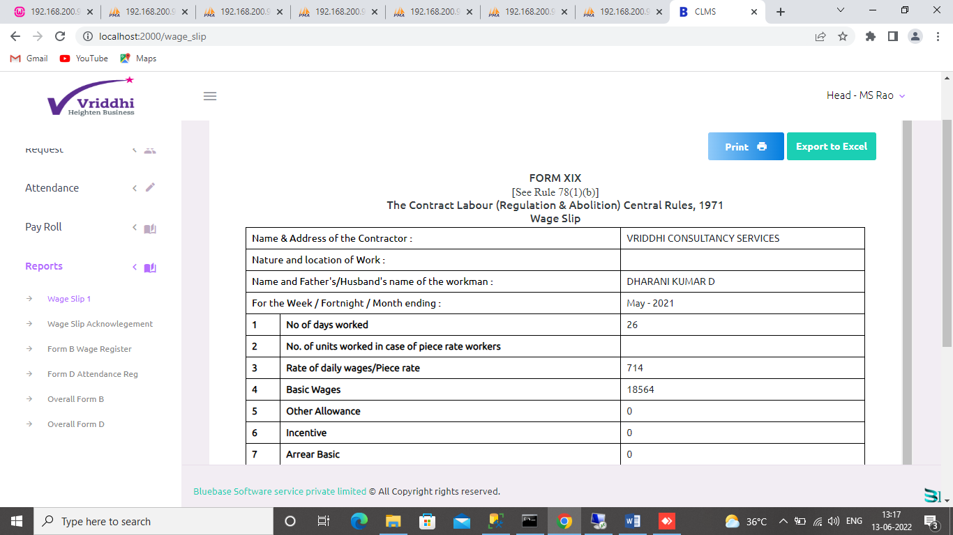
Wage slip Acknowledgement Report:
This is the wage slip acknowledgement report and you can take print and export the report.

Wage slip 2:
This is the wage slip 2 report and you can take print and export the report.

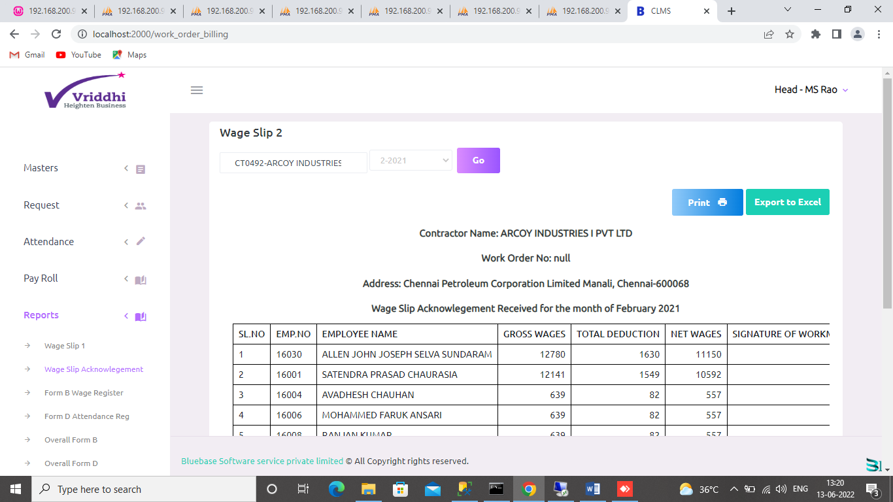
Form B Wage Register:
This is the form B wage register. You can take print and export to excel.
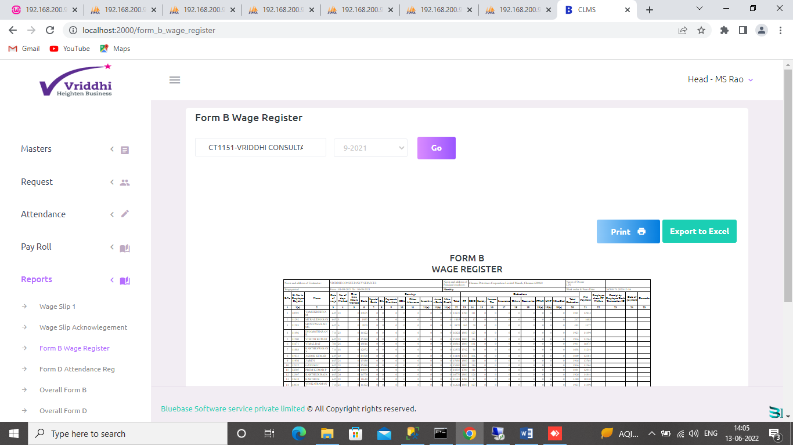
Form D wage register:
This is the form D wage register. You can take print and export to excel.
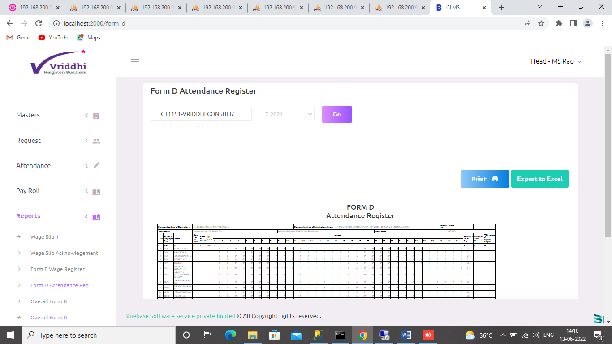
Overall Form B:
This is the overall form B report for all the contractor of given month.
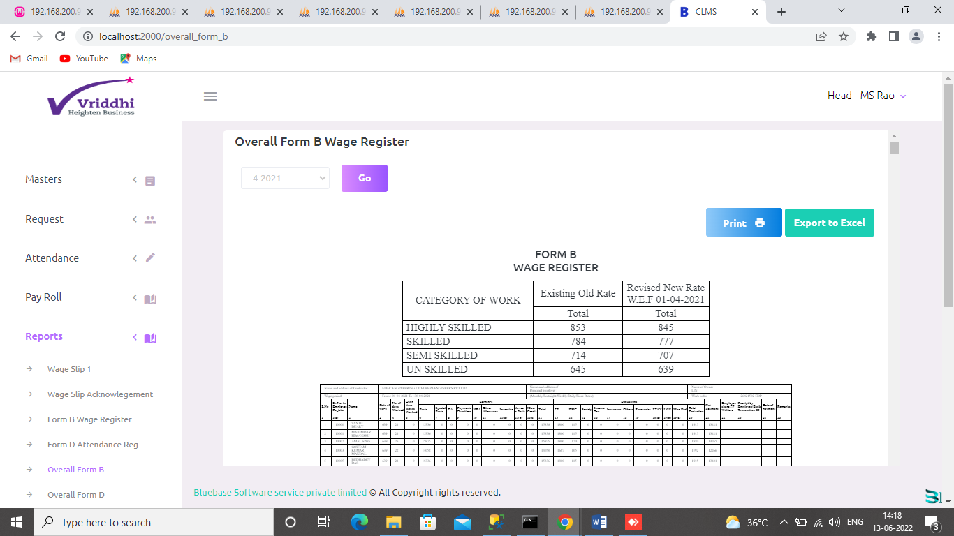
Overall Form D:
This is the overall form D report for all the contractor of given month.
